ECON/ENG/PHIL 357: Topics in Humanomics
The Ethics and Economics of Women’s Freedom

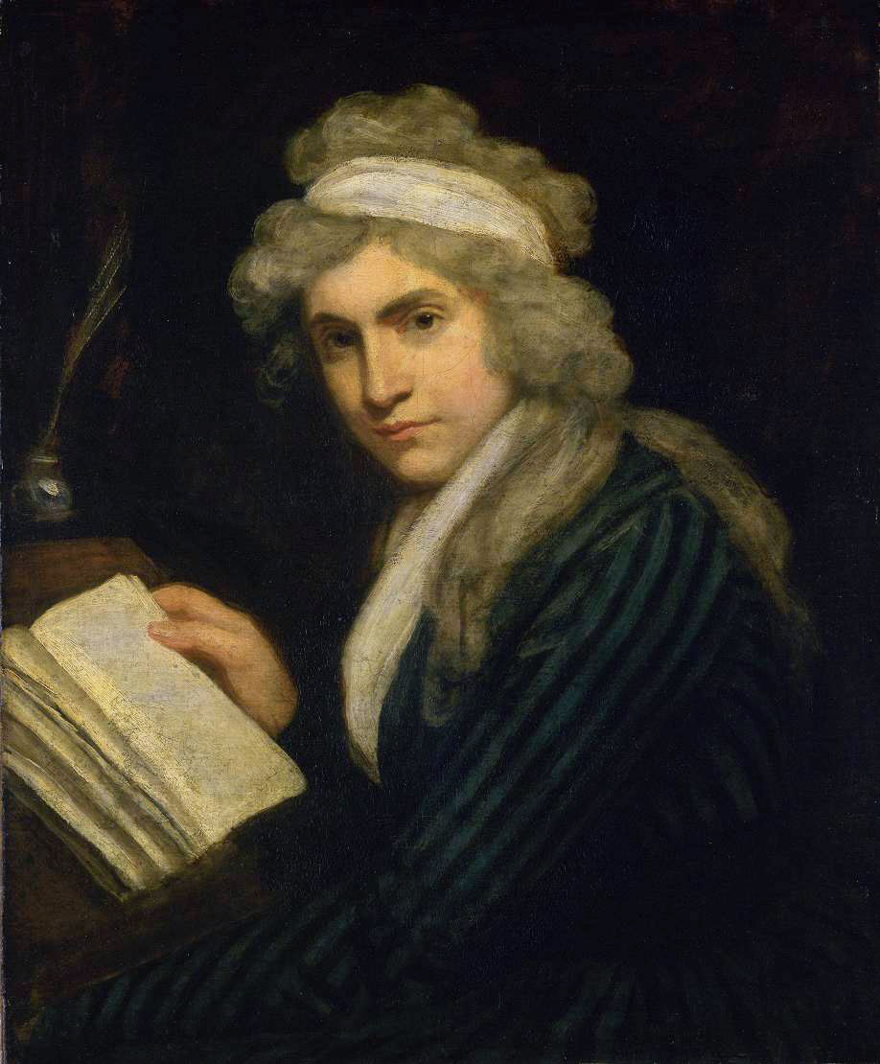

Professors Katharine Gillespie Moses and Bas van der Vossen
Chapman University
Interterm 2020

COURSE SYLLABUS
ECON/ENG/PHIL 357:
Topics in Humanomics
The Ethics and Economics of Women’s Freedom
Professors Katharine Gillespie Moses and Bas van der Vossen

COURSE DESCRIPTION
Is liberty universal? Are women less able to be and feel free than men? Are they subject to physical, social, philosophical, religious, political and/or economic constraints that disable them from achieving the same sorts of liberty as men do? Or are they able to exercise freedom in the same way as men do or even in ways that men cannot? And what are the consequences of women enjoying equal rights and freedom? In this course, we will explore these fundamental and still highly important questions about gender equality by reading political theory by John Locke and work on the economics of the family by Gary Becker’s alongside important feminist texts by Mary Wollstonecraft, Virginia Woolf and other Englishwomen who wrote in earlier centuries.

Humanomics classes (like this one) adopt a distinctively interdisciplinary approach. Throughout the term, we will address these questions through the lenses of economics, philosophy, and art. We will not just ask what these disciplines have to say about our topic independently of one another; we will also ask how these disciplines interact, enrich each other, and have unique ways of capturing parts of reality. The overarching idea is that there are many ways of expressing important ideas and that focusing on any one form of expression (social scientific, philosophical, artistic) in isolation is bound to leave important aspects of those ideas unstated, or incompletely expressed. Moreover, by working with media situated in a variety of historical contexts, we will necessarily ask why a set of ideas have been expressed in different ways in different times and places, and how this form of expression affects what’s being said.

REQUIRED TEXTS (Students are expected to bring assigned books, along with a notebook and pen, to each discussion. No electronics allowed, except in cases of special dispensation.)

Books you should have:
- John Locke, Two Treatises of Government (1692) (Cambridge, 1994).
- Gary Becker, Treatise on the Family (Harvard, 1993).
- Mary Wollstonecraft, “A Vindication of the Rights of Woman” (1791) (Cambridge, 1995).
- Virginia Woolf, “A Room of One’s Own” (1929) (Macmillan 2017).

Writings available online:
- Sophia, “Woman not Inferior to Man: or, a Short and Modest Vindication of the Natural Right of the Fair-Sex to a Perfect Equality of Power, Dignity and Esteem with the Men.”
https://digital.library.upenn.edu/women/sophia/woman/woman.html
- Sarah Fyge Egerton, “Female Advocate or, an Answer to a Late Satyr Against the Pride, Lust and Inconstancy, &c. of Woman. Written by a Lady in Vindication of her Sex” (1686).
http://www.eighteenthcenturypoetry.org/works/oae86-w0010.shtml
- Mary Astell, “Some Reflections Upon Marriage” (1700) (Ecco 2010).
https://archive.org/stream/somereflectionsu00aste#page/132/mode/2up/search/The+better+our+lot+is+in+this+world%2C
- Mary Collier, “The Woman's Labour” (poem) (1739). https://www.usask.ca/english/barbauld/related_texts/collier.html

Writings available on blackboard:
- Amy Louise Erickson (2007) “Possession—and the other one‐tenth of the law: assessing women's ownership and economic roles in early modern England” Women's History Review 16(3): 369-385
- Rick Geddes and Dean Lueck, “The Gains from Self-Ownership and the Expansion of Women’s Rights.” The American Economic Review 92 (2002): 1079-1092
- Francis Poulain de la Barre, “The Woman as Good as the Man: Or, The Equality of Both Sexes” (1677) (Wayne State University Press, 1988).

EVALUATION
Because of the interactive nature of the class, attendance is an essential component. Excessive tardies constitute absences; three absences may result in failure (Undergraduate Catalog, “Academic Policies and Procedures.”) Please keep this in mind. Missed in-class work cannot be made up.

1. Participation in Class Discussion [10%]
Class discussion provides an opportunity for students to explore questions about consumerism. Through this shared inquiry, students gain experience reading for meaning and communicating complex ideas; thinking reflectively about an interpretive problem; and supporting and testing thoughts through dialogue with peers. Class discussion fosters the flexibility of mind to consider problems from multiple perspectives and the ability to analyze ideas critically. Students must enter the discussion with specific questions generated by the texts as well as a desire to probe and reevaluate ideas. It is essential that students bring texts and questions to each class session.

2. Written Questions [10%] - Guidelines for Asking Questions
Shared inquiry is a process for exploring the central ideas of the course. This means students must read for meaning, identifying possible interpretative problems they would like to address in discussion. For each class period with an assignment, students will word process in advance two questions to be handed in before class starts. Asking a good question is harder than providing a good answer. The student’s task is to delve into a claim or idea they find puzzling, exploring what has unsettled them.

3. Writer’s Workshop [25%]
The writer's workshop is based on the idea that students learn to write when they write often; in this case, focusing their attention on ideas from the readings and discussions immediately preceding the workshop. An important component of these assignments is to understand each week’s media in their social scientific, philosophical, and/or artistic context. Students will encounter a variety of writing assignments for workshop, including both critical and creative works. Students will be asked to produce a number of papers, of approximately 250 words, and submit a polished piece at the end of the hour.

4. Papers – Expository and Creative [40% = 2 x 20% each] - Guidelines for Paper Formatting
In addition to the writer’s workshop papers, students will complete two major papers in the course, one expository/critical and one creative in nature. These papers will provide opportunities for students to explore ideas and use texts to add to the ongoing discourse. The second paper, which requires students to produce their own artistic work, such as a short story or a scene, will challenge students to analyze and embody conceptually the idea of artistic form. Provide two printed copies.

5. Oral Final Examination [15%]
Students will consider the course objectives for this course and respond to questions posed by the professors in an oral examination.

ATTENDANCE POLICY
Because of the interactive nature of the class, attendance is an essential component. Excessive tardies constitute absences; three absences may result in failure (Undergraduate Catalog 2017-2018, “Academic Policies and Procedures”). Missed in-class work cannot be made up. (Please note that each meeting-hour missed represents one absence.)

READING SCHEDULE

Week One
M 1/6: 9:00am-10:00am
Book 1 of Genesis.
10:00am-11:00am:
Writing Workshop
11:00am-12:00pm
Rachel Speght, "A Mouzell for Melastomus" (1617).

T 1/7: 9:00am-10:00am
John Locke, Two Treatises, Two Treatises,Book II, Chapter2, “Of the State of Nature.”
10:00am-11:00am:
Writing Workshop.
11:00am-12:00pm
Rachel Speght, "A Mouzell for Melastomus" (1617).

W 1/8: 9:00am-10:00am:
John Locke, Two Treatises, Book II, Chapter5, “Of Property.”
10:00am-11:00am:
Writing Workshop.
11:00am-12:00pm:
Mary Collier, “The Woman's Labour” (poem) (1739).

R 1/9: 9:00am-10:00am:
Locke, Chapter 5 “Of Property”
10:00am-11:00am:
Writing Workshop.
11:00am-12:00pm:
Amy Erickson, “Possession—and the other one‐tenth of the law: assessing women's ownership and economic roles in early modern England”

Week Two
M 1/13: 9:00am-10:00am:
Locke, Book II, Chapter 6, “Of Paternal Power,” Chapter 7, “Of Political or Civil Society,” and Chapter 8, “Of the Beginning of Political Societies,”
10:00am-11:00am:
Writing Workshop.
11:00am-12:00pm:
Mary Astell, “Some Reflections Upon Marriage (1700), Appendix, pp. 133-151

T 1/14: 9:00am-10:00am:
John Locke, Two Treatises, Chapter 4, “Of Slavery,” and Chapter 18, “Of Tyranny,”
10:00am-11:00am:
Writing Workshop.
11:00am-12:00pm:
Mary Astell, “Some Reflections Upon Marriage (1700), Appendix, pp. 151-180

W 1/16: 9:00am-10:00am:
Mary Wollstonecraft, “A Vindication of the Rights of Woman” (1791), Chapters 1-3.
10:00am-11:00am:
Writing Workshop.
11:00am-12:00pm:
Wollstonecraft, “A Vindication of the Rights of Woman” (1791), Chapters 4-5.

R 1/17: 9:00am-10:00am:
Wollstonecraft, “A Vindication of the Rights of Woman” (1791), Chapters 6-9.
10:00am-11:00am:
Writing Workshop.
11:00am-12:00pm:
Wollstonecraft, “A Vindication of the Rights of Woman” (1791), Chapters 10-13.

Week Three
T 1/21: 9:00am-10:00am:
Harriet Taylor, “Enfranchisement of Women” (1851).
10:00am-11:00am:
Writing Workshop.
11:00am-12:00pm:
Rick Geddes and Dean Lueck, “The Gains from Self-Ownership and the Expansion of Women’s Rights.”

W 1/22: 9:00am-10:00am:
Gary Becker, A Treatise on the Family, Chapter 2, “Division of Labor in Households and Families.”
10:00am-11:00am:
Writing Workshop.
11:00am-12:00pm:
De la Barre, “The Woman as Good as the Man,” “The Second Part.”

R 1/23: 9:00am-10:00am:
Becker, Chapter 4, “Assortative Mating in Marriage Markets.”
10:00am-11:00am:
Writing Workshop.
11:00am-12:00pm:
De la Barre, “The Woman as Good as the Man,” “The Second Part.”

Week Four
M 1/27 9:00am-10:00am:
Becker, “A Treatise,” Chapter 4, “The Demand for Children”
10:00am-11:00am:
Writing Workshop.
11:00am-12:00pm:
Sarah Fyge Egerton, “Female Advocate or, an Answer to a Late Satyr Against the Pride, Lust and Inconstancy, &c. of Woman. Written by a Lady in Vindication of her Sex” (poem) (1686).

T1/28: 9:00am-10:00am:
Virginia Woolf, A Room of One’s Own, Chapters 1-2.
10:00am-11:00am:
Writing Workshop.
11:00am-12:00pm:
Woolf, A Room of One’s Own, Chapters 3-4.

W1/29: 9:00am-10:00am:
Becker, “A Treatise”, Chapter 11, “The Evolution of the Family”
10:00am-11:00am:
Writing Workshop.
11:00am-12:00pm:
Woolf, A Room of One’s Own, Chapters 5-6.

R1/30: FINAL EXAM

PROGAM LEARNING OUTCOMES
Upon completion of the course, students will have:
- Composed critical and creative works motivated by theories of freedom, equality, women’s rights, and their economic dimensions
- Explored and explained processes by which humans develop social and/or historical perspectives.
- Explored and explained values, ethical perspectives and social perspectives on individual rights, women’s rights, and freedom more generally.

Students will be able to critically analyze and communicate complex issues and ideas in a variety of genres, historical periods, and global contexts. They will work independently and collaboratively to explore issues and questions that have engaged historians, philosophers, artists scientists, economists and political theorists for centuries.

COURSE LEARNING OUTCOMES:
Upon completion of the course, students will be able to:
- Challenge and deconstruct the perceived tensions between economics and the humanities.
- Ask cogent, thought-provoking questions based upon critical reading of texts across a range of literary, philosophical, and historical genres.
- Explain theories of freedom, rights, equality, feminism, as well as their economic implications; articulate their assumptions and their implications.
- Articulate how texts across the disciplines are co-constitutive of knowledge, ethics, and aesthetics.
- Demonstrate thoughtful rhetorical choices in creative and expository prose.

GENERAL EDUCATION CATEGORIES:
- AI/Artistic Inquiry: Student composes critical or creative works that embody or analyze conceptually an artistic form at a baccalaureate/pre-professional level.
- SI/Social Inquiry: Student identifies, frames and analyzes social and/or historical structures and institutions in the world today.
- VI/Values/Ethical Inquiry: Student articulates how values and ethics inform human understanding, structures, and behavior.

PREQUISITES
Sophomore standing and a disposition to inquire and be challenged.

ESSENTIAL FACILITY
Seminar setting. Access to printer and paper to print out all readings for which internet links are provided and bring them to class in hard copy form.

INSTRUCTIONAL METHODS
This course uses a combination of hands-on learning in Socratic roundtable discussions of readings, focused in-class writings, and three papers (expository and creative). Students are expected to bring the assigned reading to each discussion in book or hard copy form.

INSTRUCTIONAL STRATEGIES/LEARNING ACTIVITIES
1. Assigned readings.
2. Oral Exams.
3. Class discussions.
4. Written and oral analyses.

STUDENTS WITH DISABILITIES
In compliance with ADA guidelines, students who have any condition, either permanent or temporary, that might affect their ability to perform in this class are encouraged to contact the Office of Disability Services. If you will need to utilize your approved accommodations in this class, please follow the proper notification procedure for informing your professor(s). This notification process must occur more than a week before any accommodation can be utilized. Please contact Disability Services at (714) 516-4520 or (www.chapman.edu/students/student-health-services/disability-services) if you have questions regarding this procedure, or for information and to make an appointment to discuss and/or request potential accommodations based on documentation of your disability. Once formal approval of your need for an accommodation has been granted, you are encouraged to talk with your professor(s) about your accommodation options. The granting of any accommodation will not be retroactive and cannot jeopardize the academic standards or integrity of the course.

CHAPMAN UNIVERSITY ACADEMIC INTEGRITY POLICY
Chapman University is a community of scholars, which emphasizes the mutual responsibility of all members to seek knowledge honestly and in good faith. Students are responsible for doing their own work, and academic dishonesty of any kind will not be tolerated anywhere in the university. Please see the full description of Chapman University’s policy on Academic Integrity at www.chapman.edu/academics/academicintegrity/index.aspx.

CHAPMAN UNIVERSITY’S EQUITY AND DIVERSITY POLICY
Chapman University is committed to ensuring equality and valuing diversity. Students and professors are reminded to show respect at all times as outlined in Chapman’s Harassment and Discrimination Policy. Please see the full description of this policy at http://www.chapman.edu/faculty-staff/human-resources/eoo.aspx. Any violations of this policy should be discussed with the professor, the dean of students and/or otherwise reported in accordance with this policy.

